EFFECT OF SOCIAL MEDIA ON MENTAL HEALTH
Submitted by

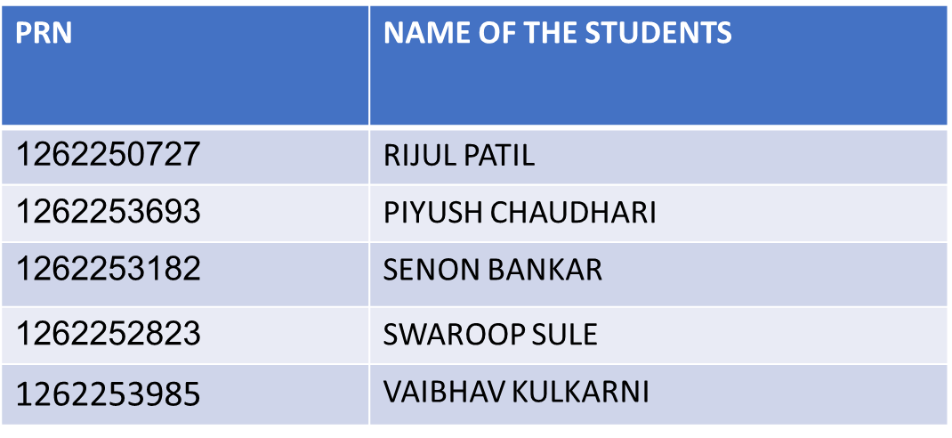

Under the Guidance of:

Prof. Madhuri Bhalekar

Abstract: The rapid growth of social media has significantly transformed communication patterns, particularly among young users. While these platforms offer opportunities for connection and information sharing, excessive usage has been linked to various mental health concerns such as anxiety, stress, low self-esteem, and sleep disturbances.

List of Abbreviations
- Abbreviation | - Full Term | - Context in Code / Project Use
SM | Social Media | General project topic, dataset label
MH | Mental Health | Used in analysis and variable names
ST | Screen Time | Column representing daily usage time
AID | Anxiety Index Data | A variable storing anxiety-related scores
SID | Stress Index Data | Stores values related to stress levels
LS | Life Satisfaction | Used for comparison with social media usage
DF | DataFrame | Pandas structure used to store and process data
CSV | Comma Separated Values | File format for importing dataset
VIS | Visualization | Used when generating graphs (matplotlib)
Corr | Correlation | Used to calculate relationships between variables
Avg | Average | Used during statistical calculations
Var | Variable | General coding term for data containers
NumPy | Numerical Python | Used for mathematical operations
PLT | Matplotlib.pyplot | Used for generating bar charts, line graphs
ML | Machine Learning | Optional extension for predictions (if used)

- Introduction:
Social media has become an inseparable part of modern life, especially among teenagers and young adults. While it offers many benefits such as easy communication, information sharing, and entertainment, its growing influence on mental health has become a serious concern. Excessive use of social media can lead to issues like anxiety, stress, low self-esteem, loneliness, and disturbed sleep patterns.
- Problem Statement:
With the increasing use of social media among individuals, especially students and young adults, concerns about its impact on mental health are rising. Many users spend long hours on platforms like Instagram, Facebook, and Twitter, which may lead to stress, anxiety, low self-confidence, and reduced real-life interactions. However, the exact relationship between social media usage and mental health is often unclear due to lack of structured data and proper analysis. This project aims to identify and analyze how different levels of social media usage influence mental health indicators such as stress, anxiety, mood, and overall well-being using Python-based data analysis.

- Python Concepts Used and Explanation:

1. Importing Libraries

Concepts Used
- import pandas as pd
- import numpy as np
- import matplotlib.pyplot as plt

Explanation
These libraries are used for:
- pandas → data loading, cleaning, and analysis
- numpy → mathematical operations and handling missing values
- matplotlib → creating plots (graphs, charts)

2. Reading a CSV File

Code
df = pd.read_csv("social_media_health_extended_big.csv")

Explanation
read_csv() loads external dataset into a DataFrame so you can analyze it.

3. Displaying Data
print(df.head())

Explanation
- df.head() shows the first 5 rows of the dataset to understand its structure.

4. Removing Duplicate Data
df = df.drop_duplicates()

Explanation
Removes repeated rows so the analysis is clean and accurate.

5. Defining a Function

Code
def clean_number(x):
...

Explanation
Your project defines a custom cleaning function to:
- Convert values to string
- Remove unwanted characters
- Handle missing values
- Keep only digits and dots
This is used to clean columns that contain numeric values mixed with text.

6. Looping Through Characters

Code
for ch in x:
...

Explanation
A for-loop is used to check every character in a string and keep only numeric values.

7. Using apply() Function

Code
df["screen_time_before_sleep"] = df["screen_time_before_sleep"].apply(clean_number)

Explanation
apply() runs your custom function on every value in a column.
Used here for data cleaning.

8. Converting Data Types

Code
df[col] = pd.to_numeric(df[col], errors="coerce")

Explanation
Converts values into proper numbers.
Invalid values = converted to NaN.

9. Handling Missing Values (NaN)
Use of:
- np.nan
- replacing empty strings
- detecting "N/A", "None", "Unknown"

Explanation
Ensures all missing data is standardized so analysis works correctly.

10. Filtering and Selecting Data

Code Example
anxiety = df["anxiety_level"]
sleep = df["sleep_hours_avg"]

Explanation
Selecting a single column from the DataFrame for analysis.

11. Calculating Correlation

Code
correlation = anxiety.corr(sleep)

Explanation
Finds statistical relationship between:
- Anxiety level
- Sleep duration
Uses Pearson correlation.

12. Conditional Statements

Code
if correlation > 0:
...
elif correlation < 0:
...
else:
...

Explanation
Used to interpret correlation as:
- Positive
- Negative
- No correlation

13. Plotting Graphs (Matplotlib)
Examples used:
- Bar plot
- Line plot
- Pie chart

Explanation
Graphs help visualize how social media affects sleep, stress, anxiety, etc.

14. Exporting Data

Code
df.to_csv("cleaned_data.csv", index=False)

Explanation
Saves cleaned dataset to a new CSV file.

2. Data Structures

Dataset Structure Table
Column Name | Data Type | Description / Meaning
user_id | Integer | Unique ID assigned to each participant
age | Integer | Age of the participant
gender | String | Gender of participant (Male/Female/Other)
daily_screen_time | Float | Total hours spent on social media per day
screen_time_before_sleep | Float | Hours spent using phone before sleeping
platform_used_most | String | Most frequently used platform (Instagram, WhatsApp, etc.)
stress_level | Integer (1–10) | Self-reported stress rating
anxiety_level | Integer (1–10) | Self-reported anxiety rating
sleep_hours_avg | Float | Average hours of daily sleep
mood_level | Integer (1–10) | Self-reported daily mood score
physical_activity | Integer (minutes/day) | Daily exercise or movement time
academic_performance | Integer (percentage) | Self-reported academic performance
social_interaction_real_life | Integer | Frequency of offline conversations/interactions
device_addiction_score | Integer | Score based on usage patterns
comments_or_posts_per_day | Integer | Engagement level (uploads, comments, posts)
mental_health_status | String | Overall mental health category (Good / Moderate / Poor)

- File Handling & Input/Output (I/O)

1. File Handling Used in Your Project
Your project uses file handling through pandas, mainly for reading and writing CSV files.

a) Reading a File (Input File Handling)
df = pd.read_csv("social_media_health_extended_big.csv")
Meaning:
- Python opens the CSV file
- Reads all the data
- Stores it in a DataFrame called df
This is input file handling because the program is taking data from a file.

b) Writing a File (Output File Handling)
After cleaning the dataset, your file contains:
df.to_csv("cleaned_data.csv", index=False)
Meaning:
- Python creates a new CSV file named cleaned_data.csv
- Saves the cleaned and processed dataset
- index=False prevents writing extra row numbers
This is output file handling because the program is saving data to a file.

2. Inputs of the File (What your program receives)
Your Python project receives the following inputs:

✔ 1. CSV Dataset Input
- social_media_health_extended_big.csv
Contains columns like:
- daily screen time
- anxiety level
- stress level
- sleep hours
- mood level
- platform used

✔ 2. User/Custom Functions Input
Your function:
def clean_number(x):
It takes string or numeric values as input and cleans them.

✔ 3. Column Values Passed to Functions
Example:
df["screen_time_before_sleep"].apply(clean_number)
The column values (strings/numbers) are input to the cleaning function.

3. Outputs of the File (What your program produces)
Your program outputs:

1. Cleaned DataFrame

2. Cleaned CSV File
3. Printed Results
4. Visual Outputs (Graphs)

Screenshots of Output: 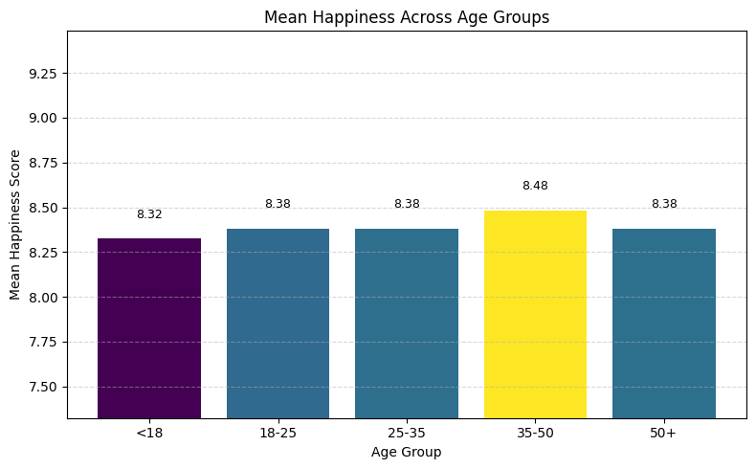

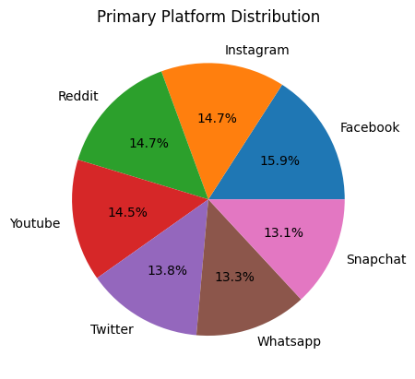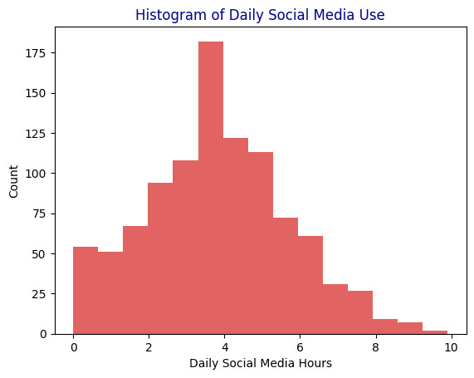

Conclusion:
- This project highlights how social media usage can significantly influence mental health, especially among young users. By analyzing the dataset using Python libraries such as pandas, NumPy, and matplotlib, clear patterns were identified between screen time, stress levels, anxiety, and sleep quality. The results show that excessive and unregulated use of social media is linked to higher stress, disturbed sleep, and reduced overall well-being. Through data cleaning, visualization, and correlation analysis, the project demonstrates how Python can effectively be used to study real-life behavioral issues

References:
- Pandas Documentation.
- NumPy Documentation.
- Matplotlib Documentation.
- American Psychological Association (APA).
- National Institute of Mental Health (NIMH).
- Dataset Source:

THANK YOU

